**Return to Foot Health: New Insights and Strategies to Manage**

**Foot-Related Pathologies**

**Speakers:** William Stodart, PT, DPT, Board-Certified Clinical Specialist in Orthopaedic Physical Therapy and Morgan Onink, PT, DPT, Board-Certified Clinical Specialist in Orthopaedic Physical Therapy

**Course Description**

Life is not easy for our feet. From the weight bearing demands placed upon them, to the variety of shoes with which we shod them, the prevalence of foot pain comes as no surprise to those in the field of physical therapy. This course will offer an advanced discussion of the foot’s functional anatomy and the pathoetiologic contributions of many common conditions involving the foot. Conventional thinking will be challenged and new, evidence-based insights for the comprehensive management of foot-related pathologies offered. An appreciation of extrinsic and intrinsic foot factors, shoewear, foot strength, and the need to consider the entire kinematic chain for the restoration foot health will be included.

**Course Objectives**

By the end of this program participants will:

1. Reflect on and reassess traditional interventions for plantar fasciitis and other foot-related pathologies
2. Develop new perspective(s) on the etiology of foot pathologies such as plantar fasciitis, tarsal tunnel syndrome, Morton’s neuroma, etc.
3. Identify contributing factors to foot-related pathologies that may not have been considered previously
4. Employ knowledge of evidence-based interventions to enhance treatment of foot-related pathologies as well as improve overall foot health
5. Develop proficiency in assessing the kinematic chain and prescribing therapeutic exercises that address the contributing factors of foot-related pathologies

**About the Speakers**

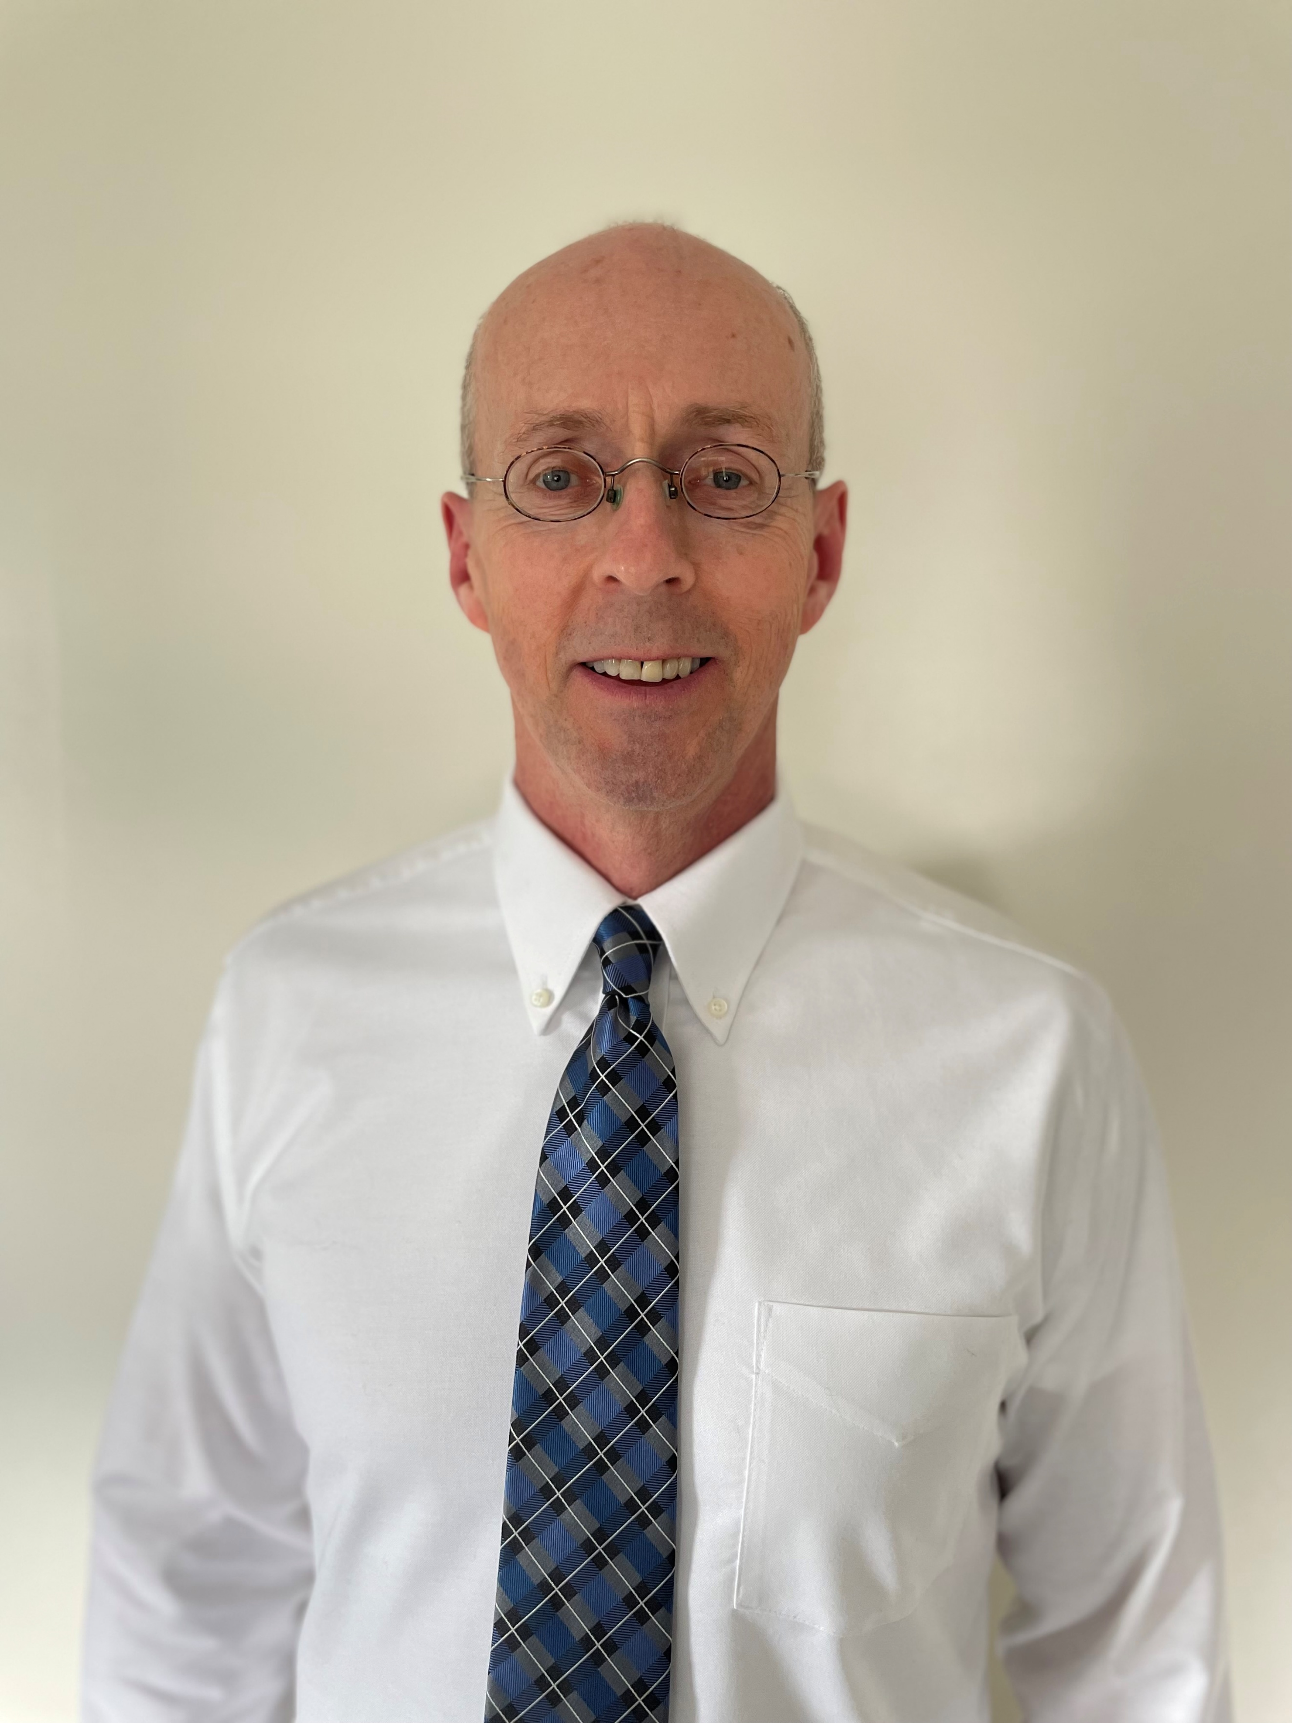

**Dr. Stodart** received his Bachelor of Science degree in Physical Therapy from the University of Pittsburgh in 1989 and his Doctor of Physical Therapy degree from Chatham University in 2007. He became a Board Certified Orthopedic Clinical Specialist in 2008; recertifying in 2016. He currently holds the rank of Associate Professor of Physical Therapy at St. Francis University where he has taught musculoskeletal content full-time since 2011. His primary teaching focus is extremity and spinal orthopedic management. He continues active clinical practice at a local outpatient facility. In addition to his teaching commitments, he enjoys running, weight-training, and recreational sports.

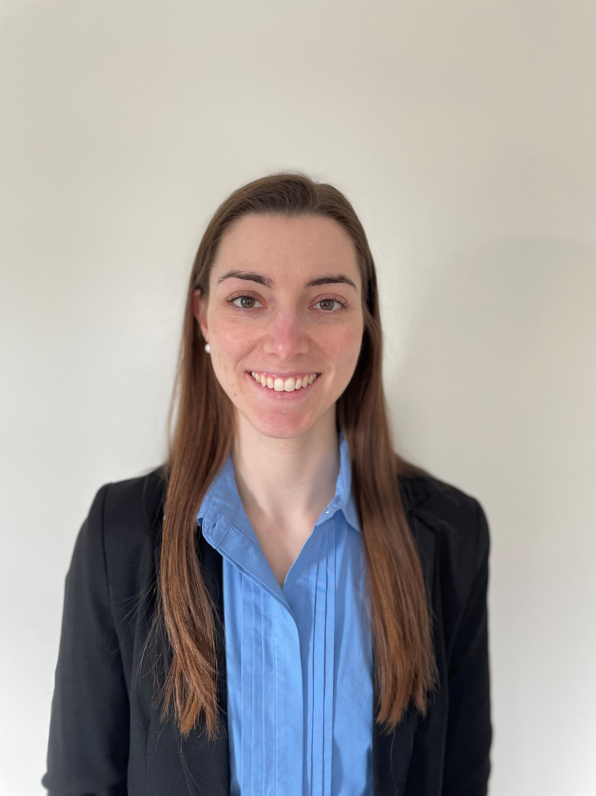

**Dr. Onink** earned both her Bachelor of Health Science and Doctor of Physical Therapy degrees from Saint Francis University in 2016 and 2019, respectively. In 2022, she became a Board Certified Orthopedic Clinical Specialist. A particular focus of her orthopedic practice is foot health, including proper shoe wear and running mechanics as well as the role of the foot in comprehensive rehabilitation of the lower extremity. She is passionate about sharing her knowledge and experience with community members, students, and fellow clinicians as she continues her personal journey of lifelong learning. Outside of physical therapy, she enjoys spending time with loved ones, being in nature, and remaining physically active.